Proof of Testing for number 4

Given values for:

Initial height: 100meters

Magnitude of Velocity: 80 meter per second

Acceleration in x-component: 2 meter per second squared

Acceleration in y-component: 9 meter per second squared

Angle in degrees: 45 degrees

Code

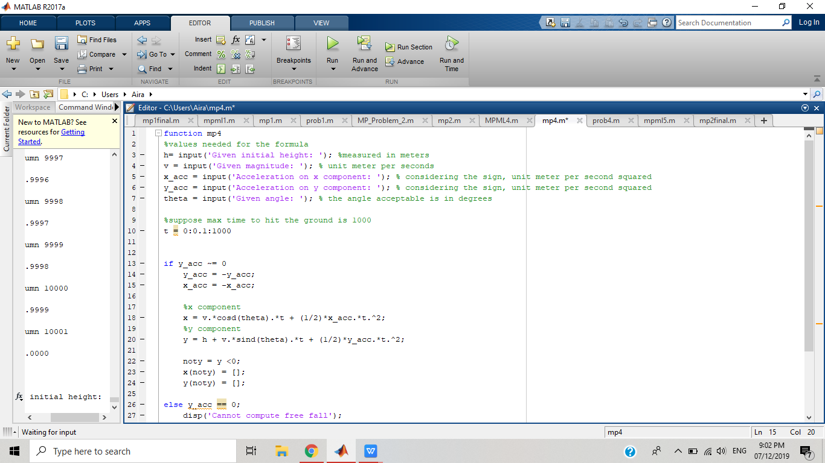

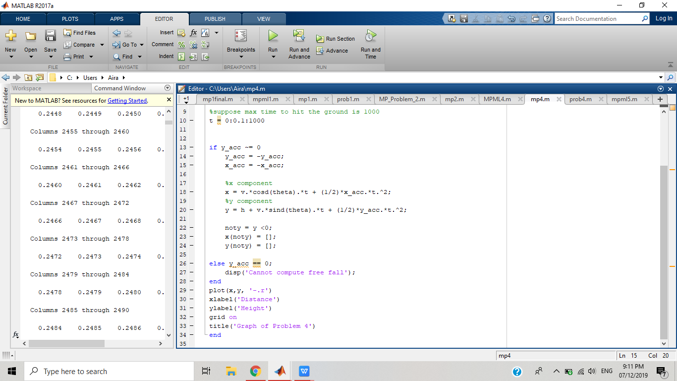

Graph

